**Practical No : 05**

**Aim :** **Aggregate functions:** **MongoDB advanced queries using aggregation**

**Q1) Insert employee (id, name, age, city, salary) collection with 10 records in the database and display all the records.**

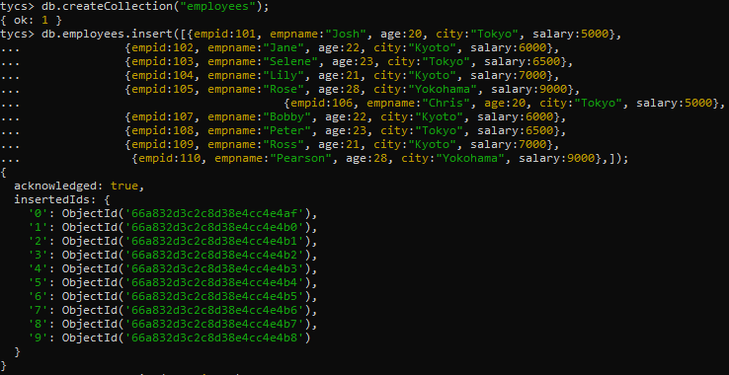

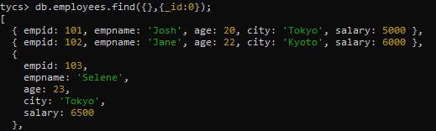

1. Group by function to get count.

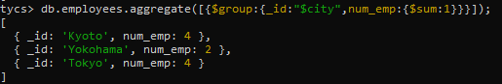db.Employee.aggregate([{$group:{_id:"$city",num_emp:{$sum:1}}}])

2. Sum function.

db.Employee.aggregate([{$group:{_id:"$city",total_sal:{$sum:"$sal"}}}])

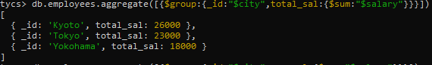

3. Avg function.

db.Employee.aggregate([{$group:{_id:"$city",avg_sal:{$avg:"$sal"}}}])

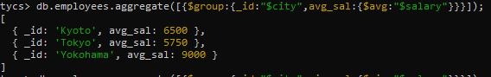

4. Min function

db.Employee.aggregate([{$group:{_id:"$city",min_sal:{$min:"$sal"}}}])

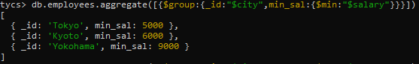

5. Max function.

db.Employee.aggregate([{$group:{_id:"$city",max_sal:{$max:"$sal"}}}])

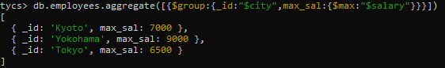

6. Push function

db.Employee.aggregate([{$group:{_id:"$city",num_tutorial:{$push:"$sal"}}}])

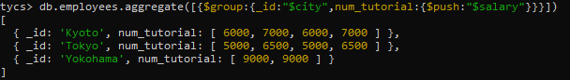

7. addToSet function

db.Employee.aggregate([{$group:{_id:"$city",url:{$addToSet:"$sal"}}}])

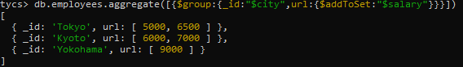

8. First function

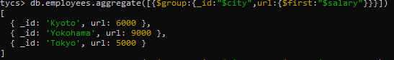

9. Last function

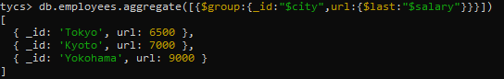

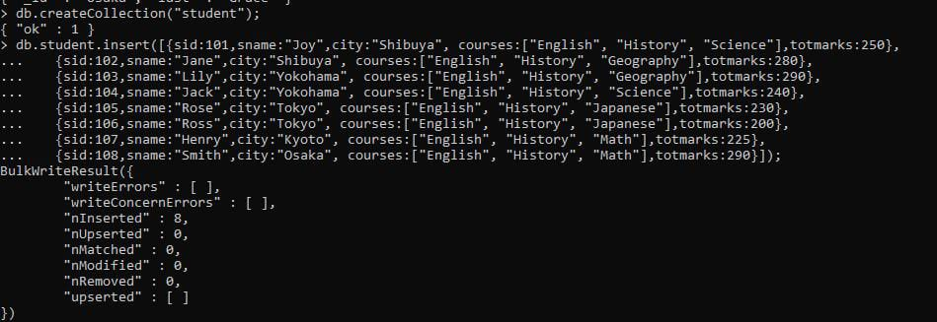**Q 2) Create a Collection Student with the following Fields (s_id,sname,age,city,courses,marks) where courses is an array perform the Following Queries based on the collection.**

1.Write a MongoDB query to use sum, avg, min and max expression.

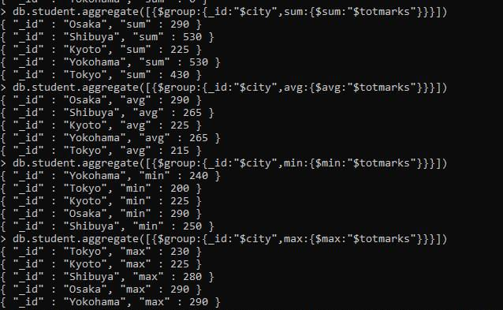

2.Write a MongoDB query to use push and addToSet expression.

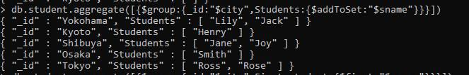

3.Write a MongoDB query to use first and last expression.

